C. Classic Visual Basic Computer Games

PREVIEW

Back in the early 1980's, there were many computers introduced to the market through such mass retailers as Sears, K Mart and JC Penneys. Names like Texas Instruments, Atari, Sinclair, Commodore, VIC and Coleco Adam appeared everywhere. Each of these computers was programmed in the BASIC language. Each computer also had monthly magazines being published containing BASIC programs you could type into your computer and play. Users eagerly awaited for each issue to have more programs for their computer. Many of these programs had roots back to the 1960's, when the BASIC language first appeared.

This chapter contains four BASIC computer games originally published using BASIC in the classic programming book called "101 Basic Computer Games" edited by David Ahl and published by DEC. The book was later re-published as "BASIC Computer Games" by David Ahl. The original games were simple 'text-only' programs. They had no fancy graphics and no sound. You had to use your imagination a lot back in those days. Much of the code is structured just like original BASIC programs. The original games were written long before the days of structured programs. However, the games are still fun and invoke a nostalgic feeling in many of us older programmers. Many of us stayed up very late at night typing in all these BASIC games on our computers just so we could learn how to program. BASIC Computer Games made learning the BASIC computer language fun and rewarding. If you would like to see all the original BASIC Computer Games we ported most of them to Microsoft Small Basic (the little cousin to Visual Basic Express). You can purchase these Special 25th and 30th Anniversary Microsoft Small Basic Edition of David Ahl’s classic programming books on our website

VISUAL BASIC PROGRAM OPERATION INSTRUCTIONS

The games were built using Visual Basic.NET and then were converted to Visual Basic Express. Visual Basic Express provides this conversion automatically when you attempt to open a Visual Basic .NET application. So, what's the difference between a Visual Basic .NET application and one built in Visual Basic Express 2012? On the surface, nothing. The controls work the same, the event methods are coded the same way. The applications can be modified using Visual Basic Express. The only difference you will note is in the application file structure. In Visual Basic .NET, all the code written by the environment to establish the controls on a form are included in the form's .vb file. This code will be seen if you expand the "Windows generated form" code icon in the code window. In Visual Basic Express, this code is maintained in a separate form designer file (a Designer.vb file, a partial Class) to keep it hidden from you. Be aware of this slight difference as you build your own Visual Basic Express programs.

The files included with VISUAL BASIC EXPRESS GAMES are in a single directory. The program files are found in the VBEGames folder. In this folder are four other folders. These folders contain the files needed for each game:

Acey - Acey-Decey program files
Even - Even Wins program files
Mugwump - Mugwump program files
Lunar - Lunar Lander program files

To install on your machine, unzip the file to the desired folder. Then, in the Visual Basic Express environment, just load and run the desired VISUAL BASIC EXPRESS GAMES program file.

ACEY DEUCEY (Original Author: Bill Palmby, Prairie View, Illinois)
BASIC COMPUTER GAMES, Edited by David H. Ahl, Published in 1978

This is one of the first computer card games ever! Two cards are listed. You bet whether the next card is between the two displayed cards. If it is, you win your bet - if not, you lose.

The game is played with a standard deck of 52 playing cards. With each turn, two cards are dealt from the deck and listed. The idea of the game is to see if the next card is between the two listed cards (if it is the same value as a listed card, it is considered to be between the values). Deuces (twos) are the lowest cards and aces are the highest cards. With each turn, your are shown your score (you start with 100 points) and you are shown how many cards are left in the deck. You are then asked to bet. On each turn, you may bet from 0 points to your score. Each turn of the game is the same. Once the cards are shown, you enter your bet and press the <Enter> key on your keyboard. The next card is then listed and checked to see if it is between the other listed cards. If it is, your bet is added to your score. If not, your bet is deducted from your score. The game ends when one of two things happens: there are not three cards left in the deck to deal or your score reaches zero.

The strategy of ACEY-DEUCEY is pretty straightforward. Make large bets when the two displayed cards are far apart. Make small bets (even zero bets) when the displayed cards are close to each other. If a deuce (two) and ace are displayed, bet the maximum because you can't lose! That's why the game is called ACEY-DEUCEY! More sophisticated players could even keep track of what cards are left in the deck to help improve odds of winning - this technique is called card counting.

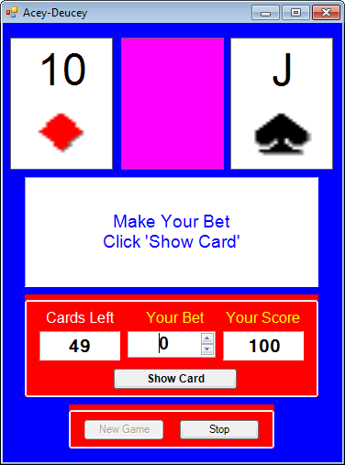

EVEN WINS (Original Author: Eric Peters of Digital Equipment Corporation) BASIC COMPUTER GAMES, Edited by David H. Ahl, Published in 1978

EVEN WINS is a game between you and the computer. To play, an odd number of markers are displayed on the screen. You take turns with the computer removing between one and four markers each turn. The game ends when there are no markers left and the winner is the one with an even number of markers removed.

When the game begins, the markers (asterisks) are displayed and the computer takes the first turn, removing from one to four markers. Then, on your turn, do the same. Remove from one to four markers by entering 1, 2, 3 or 4 key on your keyboard and pressing <Enter>. After each turn, you are shown how many markers you and the computer have. Continue alternating turns until all markers are gone. You win if you are left with an even number of markers. The computer wins if its score is an even number.

This is an interesting version of this game. The computer starts out only knowing the rules of the game and doesn't play very well. Using simple techniques of artificial intelligence, the computer gradually learns to play from its mistakes until it plays a very good game. After 20 games, the computer is a challenge to beat. Variation in your style of play seems to make the computer learn more quickly. I personally don't know how this code works - maybe you can figure it out. I just typed the code from a magazine - a technique used by many programmers (code 'borrowing').

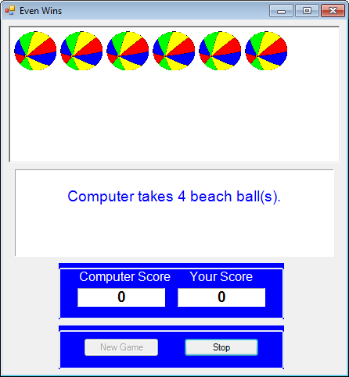
MUGWUMP (Original Author: Bob Albrecht of Peoples Computer Company)
BASIC COMPUTER GAMES, Edited by David H. Ahl, Published in 1978

The objective in this game is to find the four Mugwumps hiding on various squares of a 10 x 10 grid. After guessing a location, the computer gives you distance clues on how far you are from each Mugwump.

At the beginning of each game, a blank grid is shown. Choose a square to guess the location of a Mugwump. To choose a square, you are asked to enter the row (0 to 9) and column ( 0 to 9) of the selected square. After your guess, you are told how far (the famous Pythagorean triangle formula is used) you are from each remaining Mugwump. Use this information for your next guess. The program tells you how many Mugwumps are remaining and how many guesses you have taken. The game ends when all the Mugwumps have been found.

Playing the game with aid of graph paper and a compass should allow you to find all the Mugwumps in six or seven moves using triangulation similar to old Loran radio navigation (do some research to find out what this is).

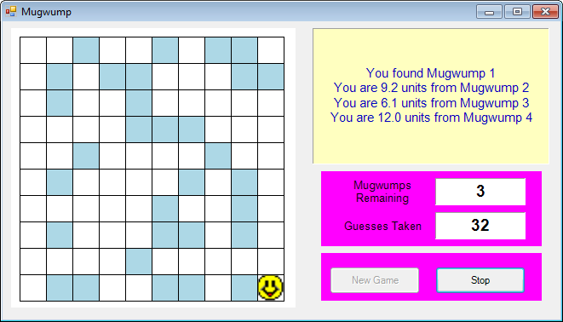
LUNAR LANDER (Original Author: Eric Peters of DEC)
BASIC COMPUTER GAMES, Edited by David H. Ahl, Published in 1978

This has been called the single most popular computer game ever. It was one of the first games written by little Billy Gates in his early programming days. You are hovering over the moon in your lunar module. You must land it safely by controlling the retrorocket burns.

When the game begins, you are 500 feet above the lunar surface and control the rocket burns in 1-second bursts. Displayed on the screen are Time, Altitude, Speed and Fuel Remaining. Each unit of fuel used slows your descent by 1 ft/sec. The maximum burn is 30 units of fuel in one second. To slow the module, enter the amount of fuel you want to burn over the next second (0 accelerates the module toward the lunar surface). Press the <Enter> key and the screen is updated with the latest data. A safe landing is achieved with final speeds less than 10 ft/sec.

The biggest mistake people make playing this game is yielding to the temptation of slowing the module much too soon. With this strategy, you run out of fuel for the lower part of the journey and the resulting free-fall is disastrous! Use small burns early on to slow slight or maintain speed (a burn of 5 units does this). Then, really crank it on near the surface. You'll find some burn rates that work well.

